To study Forward kinematics of 2 dof serial manipulators
Exp
No 3

Aim: To study Forward kinematics of 2 dof serial manipulators

Instrument required:
Desktop PC with internet connection

Forward Kinematics:
Forward kinematics (FK) in robotics determines a robot's end-effector position and orientation (pose) in 3D space based on known joint parameters—such as angles for revolute joints or displacements for prismatic joints—using mathematical transformation matrices. It is essential for path planning, simulation, and controlling robot movements.

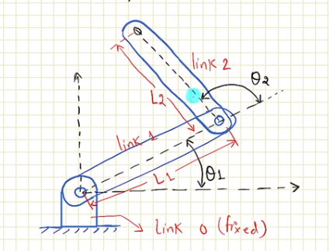

Step 1: Identify Home position:

- H Parameter Table:
Frame | $$θ_{i}$$ | $$d_{i}$$ | $$a_{i}$$ | $$α_{i}$$
$${}_{1}^{0}T$$ | $$θ_{1}$$ | 0 | L1 | 0
$${}_{2}^{1}T$$ | $$θ_{2}$$ | 0 | L2 | 0

$${}_{1}^{0}{T = Rot(Z, θ_{1}).Trans(z,0).Trans(x.l1).Rot(x,0)}$$

$${}_{2}^{1}{T = Rot(Z,θ_{2}).Trans(x,l2)}$$

$${}_{2}^{0}{T = {}_{1}^{0}T} x {}_{2}^{1}T$$
Code for Matlab:

clc
clear

syms theta1 theta2 L1 L2
%theta1 = 0;
%theta2 = 0;

A = [cosd(theta1) -sind(theta1) 0 0;
sind(theta1) cosd(theta1) 0 0;
0 0 1 0;
0 0 0 1];

B = [1 0 0 L1;
0 1 0 0;
0 0 1 0;
0 0 0 1];

C = A* B

C =
[cos((pi*theta1)/180), -sin((pi*theta1)/180), 0, L1*cos((pi*theta1)/180)]
[sin((pi*theta1)/180), cos((pi*theta1)/180), 0, L1*sin((pi*theta1)/180)]
[ 0, 0, 1, 0]
[ 0, 0, 0, 1]

D = [cosd(theta2) -sind(theta2) 0 0;
sind(theta2) cosd(theta2) 0 0;
0 0 1 0;
0 0 0 1];

E = [1 0 0 L2;
0 1 0 0;
0 0 1 0;
0 0 0 1];

F=D*E

[cos((pi*theta1)/180)*cos((pi*theta2)/180) - sin((pi*theta1)/180)*sin((pi*theta2)/180), - cos((pi*theta1)/180)*sin((pi*theta2)/180) - cos((pi*theta2)/180)*sin((pi*theta1)/180), 0, L1*cos((pi*theta1)/180) + L2*cos((pi*theta1)/180)*cos((pi*theta2)/180) - L2*sin((pi*theta1)/180)*sin((pi*theta2)/180)]
[cos((pi*theta1)/180)*sin((pi*theta2)/180) + cos((pi*theta2)/180)*sin((pi*theta1)/180), cos((pi*theta1)/180)*cos((pi*theta2)/180) - sin((pi*theta1)/180)*sin((pi*theta2)/180), 0, L1*sin((pi*theta1)/180) + L2*cos((pi*theta1)/180)*sin((pi*theta2)/180) + L2*cos((pi*theta2)/180)*sin((pi*theta1)/180)]
[ 0, 0, 1,0]
[0, 0, 0, 1]
Simlified:
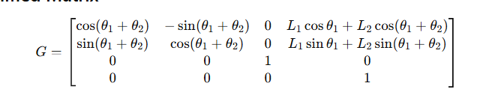

Answer:
[1, 0, 0, L1 + L2]
[0, 1, 0, 0]
[0, 0, 1, 0]
[0, 0, 0, 1]

Result:

